PHASE 5 – PROJECT DEVELOPMENT
Project Title:
Streamlining IT Procurement: Automating Standard Laptop Orders with Flow Designer
Introduction:
- The Project Development phase focuses on the actual implementation of the automated Standard Laptop procurement process in ServiceNow.
- Based on the project design and planning, the workflow is developed using ServiceNow Flow Designer. The development includes creating the Flow, configuring the Service Catalog trigger, creating a Catalog Task, assigning the task to the Hardware group, and connecting the Flow with the Standard Laptop Service Catalog item.
- The development process follows the steps provided in the project reference document.
Development Environment:
The project is developed using the ServiceNow platform.
The main ServiceNow components used during development are:
- Flow Designer
- Service Catalog
- Maintain Items
- Process Engine
- Standard Laptop Service Catalog Item
- Catalog Task
- Hardware Assignment Group
- Approval Process
These components are configured to implement the automated Standard Laptop procurement workflow.
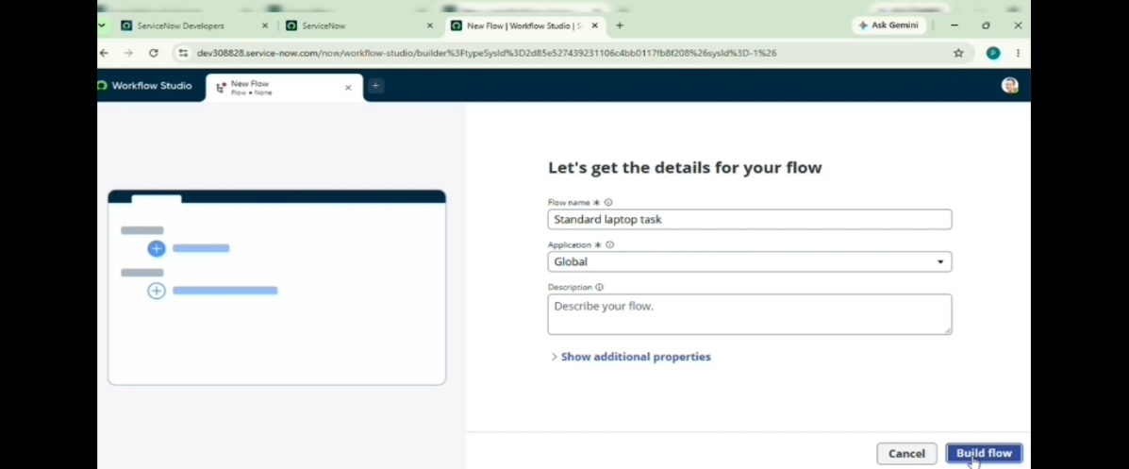

Development of Flow:
The first development activity is to create the Flow.
The following steps are performed:

1. Open ServiceNow.
2. Select All.
3. Search for Flow Designer.
4. Open Flow Designer under Process Automation.
5. Select New.
6. Select Flow.
7. Enter the Flow Name as Standard laptop task.
8. Select Global as the Application.
9. Select System user as the Run User.
10. Submit the Flow.
The Flow is now created and ready for trigger configuration.
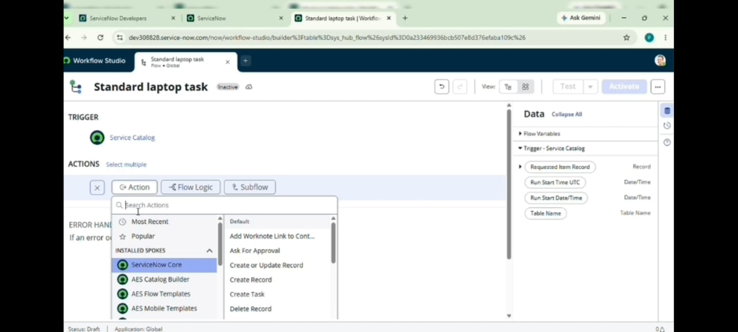

Development of Service Catalog Trigger:
After creating the Flow, the required trigger is added.
The development steps are:
1. Select Add a Trigger.
2. Search for Service Catalog.
3. Select Service Catalog.
4. Click Done.
The Service Catalog trigger is used as the starting point of the Flow.
The development flow is:
Service Catalog Request → Service Catalog Trigger

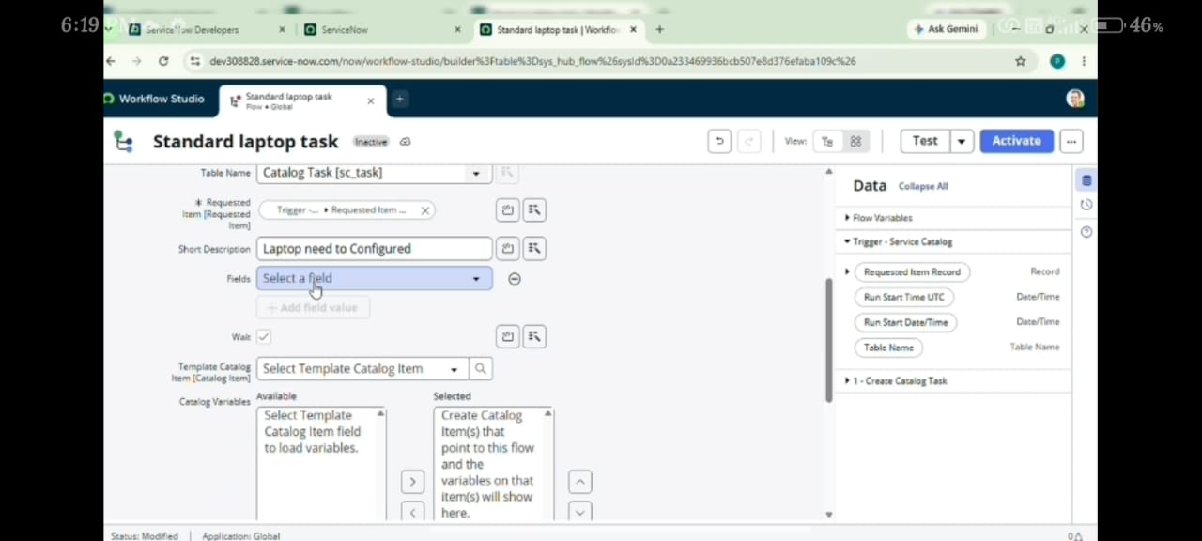

Development of Create Catalog Task Action:
After configuring the trigger, the required action is added.
The development steps are:
1. Go to Actions.
2. Select Add an Action.
3. Search for Create Catalog Task.
4. Select Create Catalog Task.
5. Use the Requested Item Record as the Request item.
6. The Table is automatically populated as Catalog Task.
This action is responsible for creating the task required for laptop configuration.

Configuration of Catalog Task Fields:
The Catalog Task fields are configured according to the project requirements.
The following values are entered:
Short Description:
Laptop need to Configured
Description:
Laptop need to Configured
Assignment Group:
Hardware
Approval:
Approved

The remaining fields are left with their default values according to the reference document.
This configuration ensures that the generated task contains the required information and is assigned to the Hardware group.

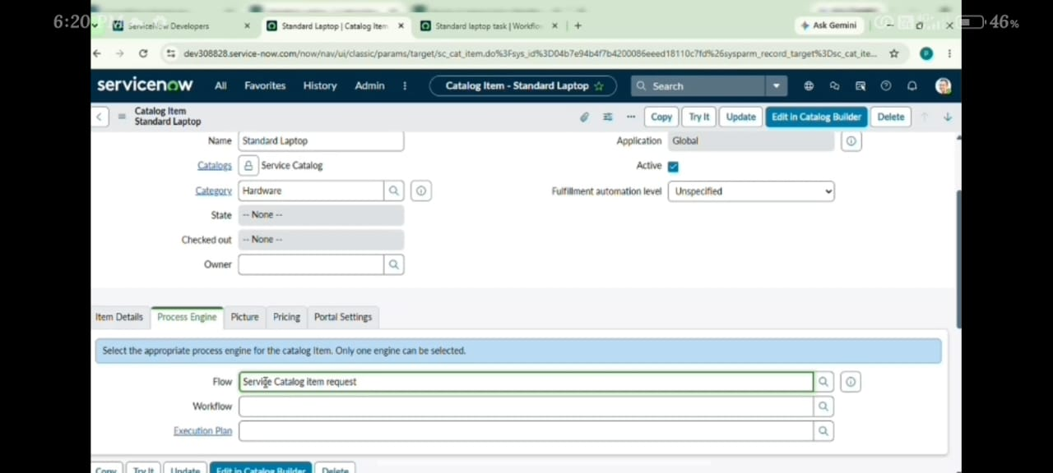

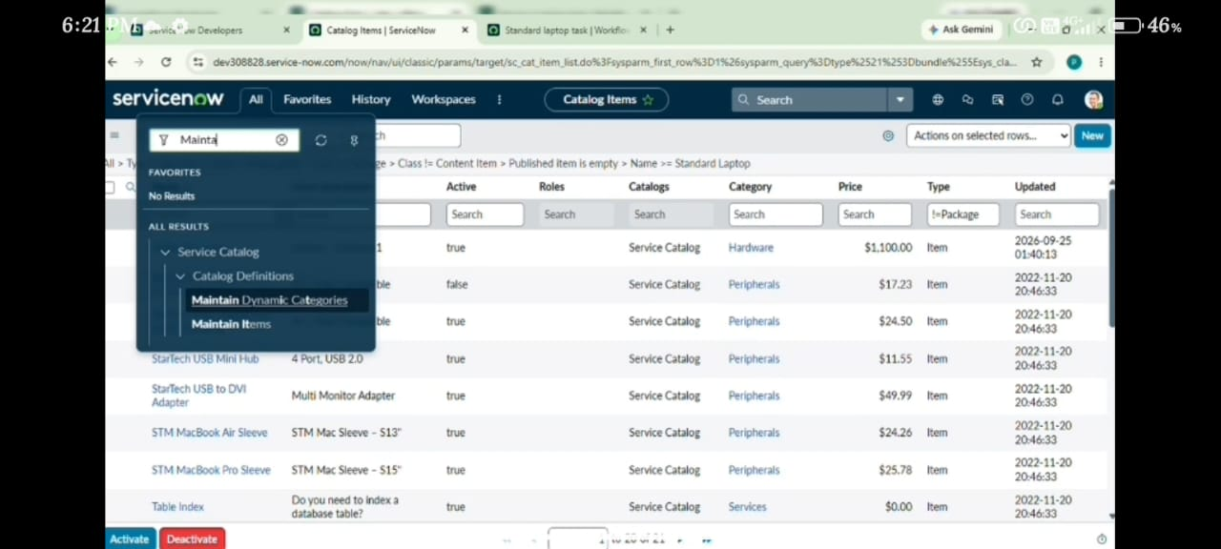

Saving and Activating the Flow:
After completing the Catalog Task configuration:
1. Click Done.
2. Save the Flow.
3. Click Activate.
4. Click Activate again when required.
The Flow is now activated and ready to be used with the Standard Laptop Service Catalog item.
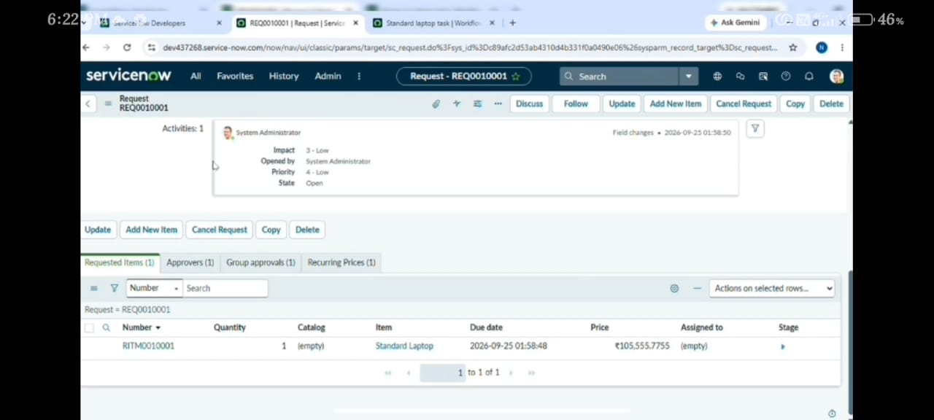

Assigning the Flow to Standard Laptop:
After developing the Flow, it is assigned to the Standard Laptop Service Catalog item.
The following steps are performed:
1. Open ServiceNow.
2. Click All.
3. Search for Maintain Items.
4. Open Maintain Items.
5. Search for Standard Laptop.
6. Select the Standard Laptop record.
7. Open the Process Engine section.
8. Remove the remaining automations as required.
9. Add a Flow.
10. Select Standard Laptop Task.
11. Save the record.
This connects the developed Flow with the Standard Laptop Service Catalog item.

Placing the Standard Laptop Request:
After assigning the Flow, the Standard Laptop request process is executed.
The following steps are performed:
1. Open Service Catalog.
2. Select Hardware.
3. Find Standard Laptop.
4. Open the Standard Laptop item.
5. Click Order Now.
The Standard Laptop request is now placed.
Request Approval:
- After placing the request, the Order Status is displayed.
- The Request Number is opened to access the requested record.
- The Approvers section is then opened and the request is approved.
The development process therefore follows:
Standard Laptop Order → Request Number → Approvers → Approve
Verification of Generated Catalog Task:
- After approval, the Requested Item section is opened.
- The generated Catalog Task is opened to check the task details.
- The Catalog Tasks section is then accessed.
The task should contain:
- Updated status
- Short Description
- Assigned Group
The expected values are:
Short Description:
Laptop need to Configured
Assigned Group: Hardware
This confirms that the developed Flow has generated the Catalog Task with the configured information.
Complete Development Workflow:
The complete development process can be represented as:
Create Flow
↓
Add Service Catalog Trigger
↓
Add Create Catalog Task Action
↓
Configure Requested Item
↓
Configure Short Description
↓
Configure Description
↓
Assign to Hardware
↓
Set Approval as Approved
↓
Save and Activate Flow
↓
Assign Flow to Standard Laptop
↓
Place Standard Laptop Order
↓
Approve Request
↓
Check Generated Catalog Task

The above sequence represents the implementation of the project in ServiceNow.

Development Components:
The following components are developed or configured during this phase:
1. Standard Laptop Task Flow
2. Service Catalog Trigger
3. Create Catalog Task Action
4. Requested Item Record
5. Catalog Task
6. Short Description
7. Description
8. Hardware Assignment Group
9. Approval Configuration
10. Standard Laptop Service Catalog Item
11. Process Engine Flow Assignment
Development Result:
- After completing the development activities, the Standard Laptop procurement workflow is implemented in ServiceNow.
- The developed Flow is connected to the Standard Laptop Service Catalog item. When a Standard Laptop request is placed and approved, the Flow creates the required Catalog Task.
- The task contains the configured short description and is assigned to the Hardware group.
Phase 5 Summary:
- The Project Development phase implements the planned Standard Laptop procurement workflow in ServiceNow.
- The Flow named Standard laptop task is created using Flow Designer with a Service Catalog trigger and a Create Catalog Task action. The Catalog Task is configured with the required description, Hardware assignment group, and approval condition.
- The developed Flow is then assigned to the Standard Laptop Service Catalog item. A Standard Laptop request is placed and approved, after which the generated Catalog Task is checked.
- The successful completion of these development activities provides the implemented workflow that can be evaluated during the Project Testing Phase.

